

Careers resources request form
If you’re a teacher, careers or employment advisor, you can request leaflets and posters from us to help you promote careers in social care.
Remember, there is also lots of information on Think Care Careers, including a dedicated web page for teachers and careers advisors. You can request an I Care…Ambassador to come and talk to your students or job seekers; they might also offer work experience or taster days.

Resources for careers events and workshops

 | Think social care leaflet | This leaflet can be used at careers events to promote social care careers. It gives an overview of the sector.
 | Job roles booklet | This booklet can be used at careers events to promote the different job roles available in social care.
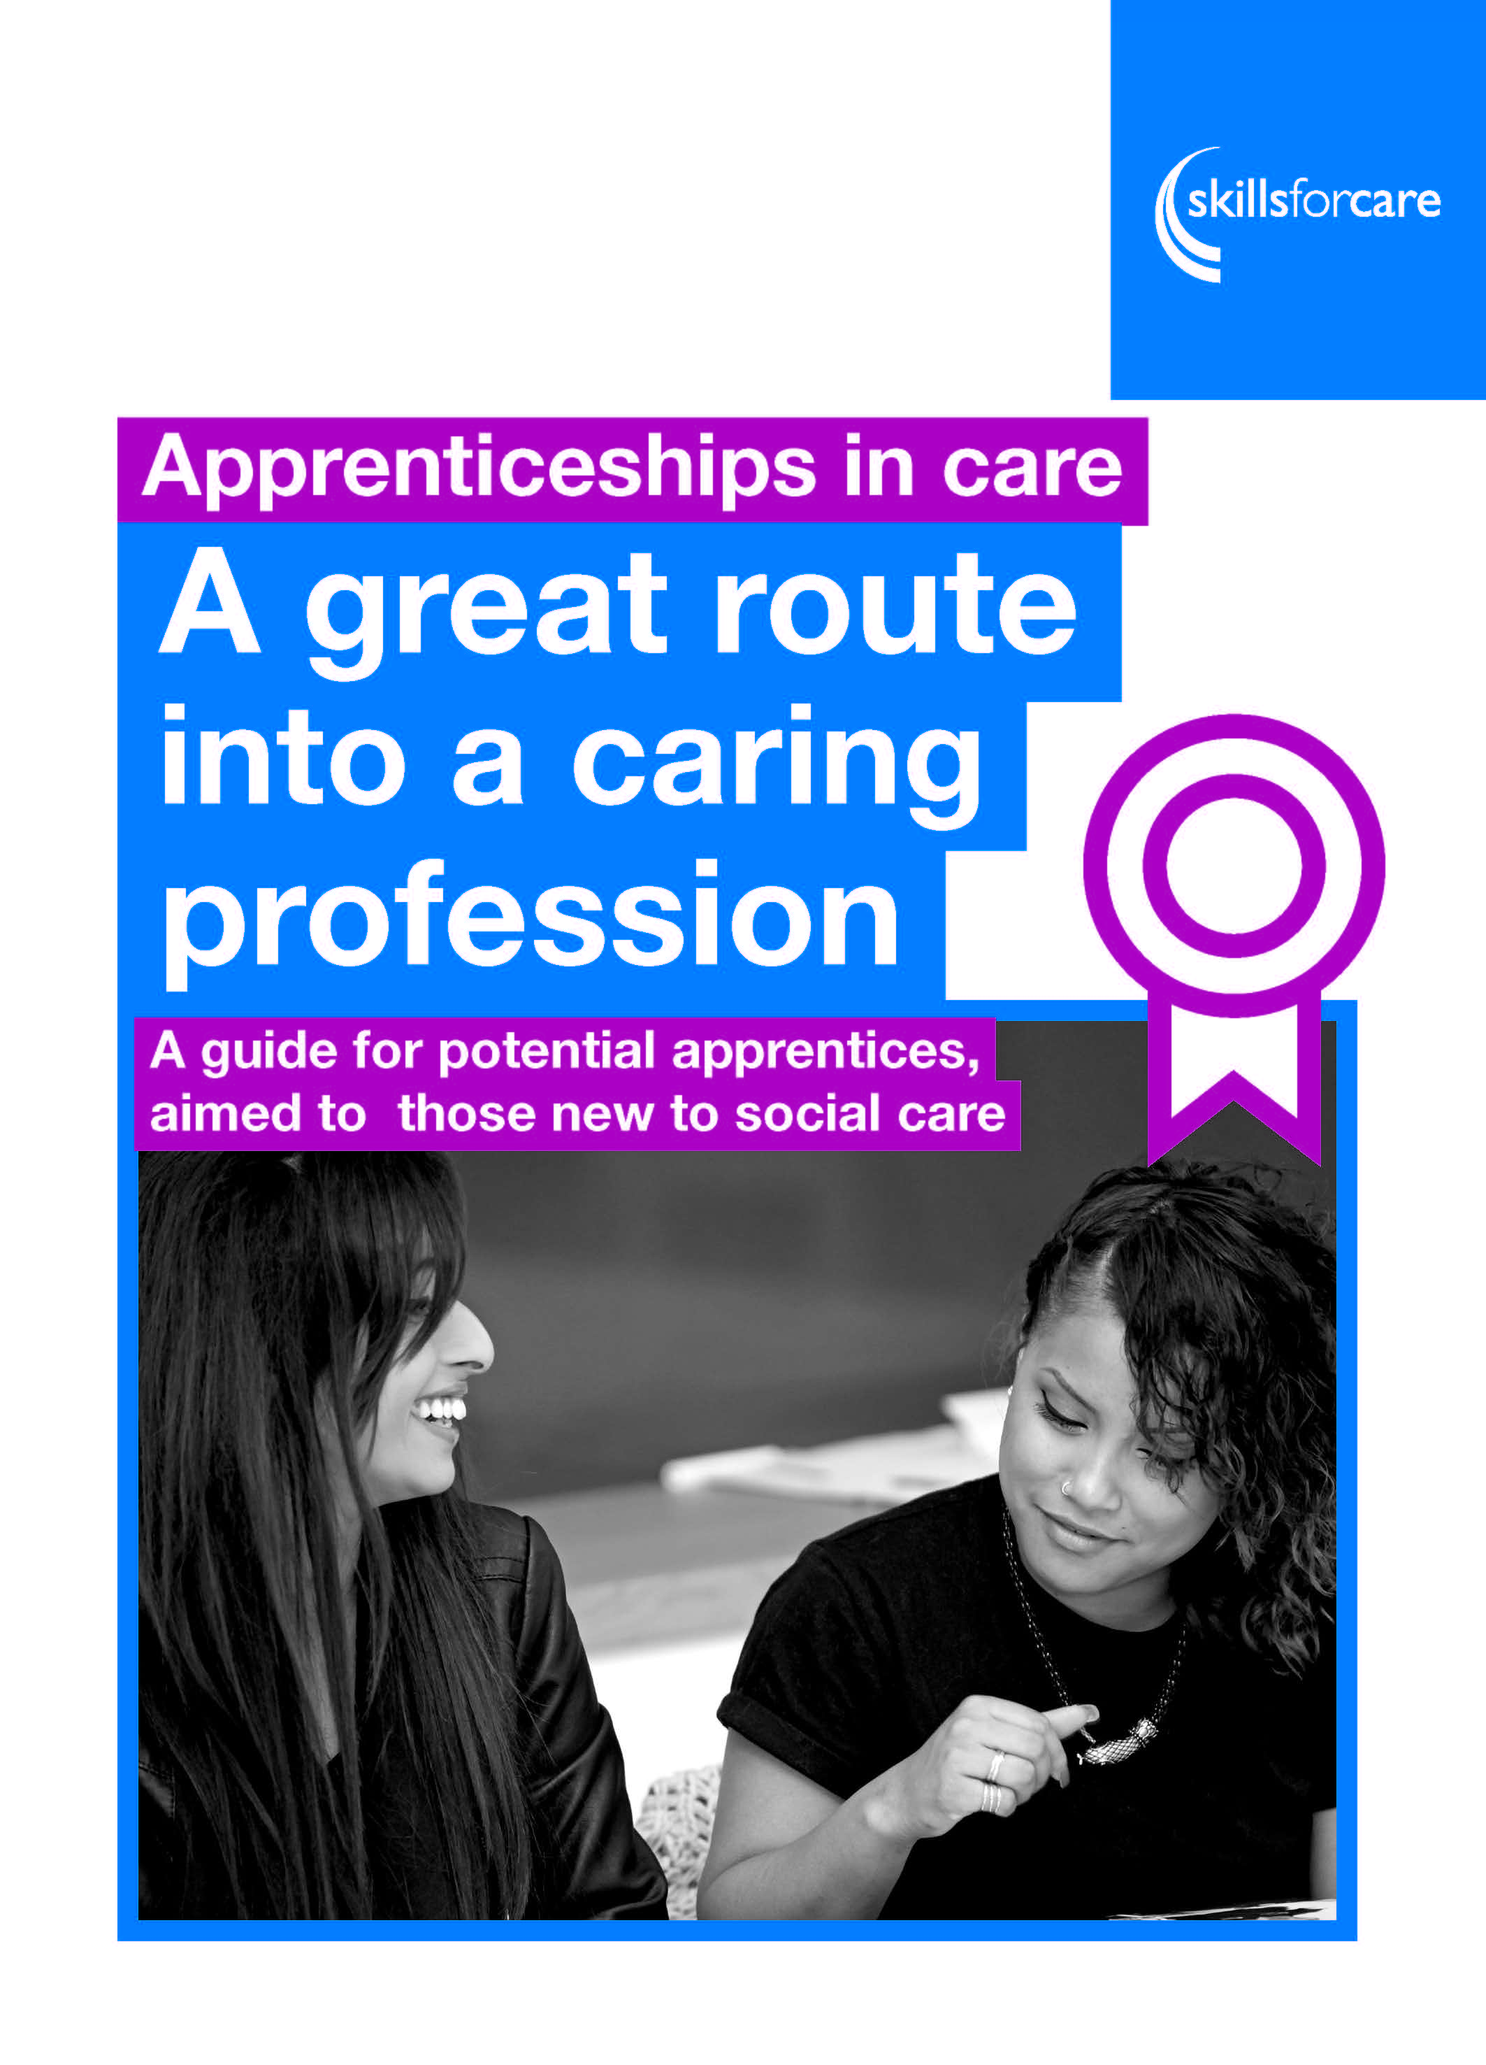 | A great route into a caring profession: a guide for potential apprentices, aimed at those new to care | This leaflet can be used at careers events to promote social care Apprenticeships.
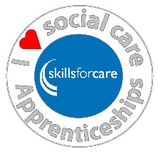 | Skills for Care pens and badges | These pens and badges can be used at careers events to give to people who take part in activities.

Delivery details:
Name
Organisation
Address
Telephone
Email
Please return to: Marketing team (careers resources request), Skills for Care, West Gate, 6 Grace Street, Leeds, LS1 2RP or email marketing@skillsforcare.org.uk

