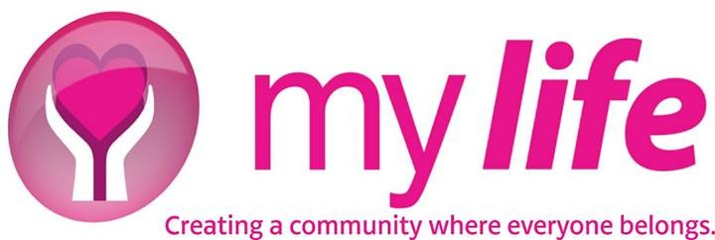
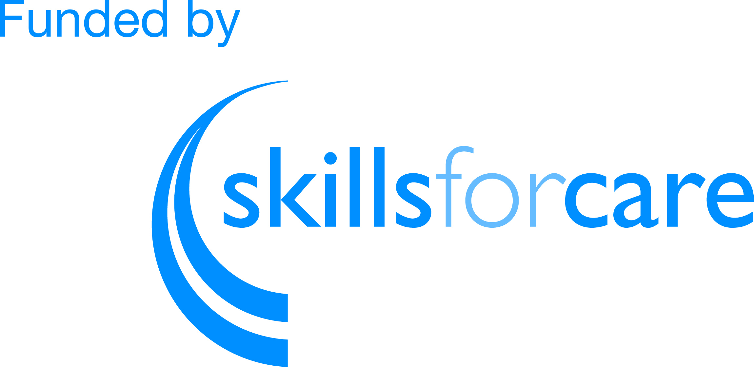

My Life

Pathways to employment: Train the Trainer sessions

Contents

Background 2
Aims 3
The Pathways to Employment model 4
Train the trainer session 8
Find out more 10

Background

My Life Legacy is a registered charity that supports individual employers to find and recruit high quality personal assistants (PAs). This enables individuals who need care and support to have more choice and control and a better quality of life.

Our founder, Caroline Tomlinson, delivers talks all over the country and recognises a national challenge with finding PAs.

We developed the Pathways to Employment model (P2E), an asset based community development approach, to support more people into the PA role. The model invites potential PAs to attend five sessions to explore more about the role, the values you need to work in social care and gives them the opportunity to meet potential employers. At the end, suitable candidates are recruited by individuals into paid jobs or voluntary work.

This has been successful locally and we wanted to share our learning and successes with the wider voluntary sector, and support them to run their own P2E programme.

To do this we designed and delivered a Train the Trainer course and offered it to other supporting organisations across England free of charge.

As part of this project we delivered a full day Train the Trainer session and gave delegates the opportunity to attend the actual P2E course. They were then offered a follow up session and ongoing mentoring to help them deliver the P2E model in their own organisation.

Aims

The aim of the project was to develop a Train the Trainer course that builds on the success of our local P2E model so it can be replicated across the country.

We wanted to:
- find at least five trainers from five different organisation who want to deliver the P2E model
- train all of the trainers to a competent level to recruit and deliver the course
- support trainers to take the learning to their own workplace and deliver the P2E model
- evaluate the success of what works and what doesn’t.

We hoped this would expand the reach of P2E to:
- support individual employers to recruit, train and retain PAs
- attract new PAs into the social care workforce
- provide training and development opportunities for PAs.

The Pathways to Employment model

P2E is a model that supports the recruitment of PAs with the right values and skills.

We developed it to meet the challenges individual employers have of finding suitable PAs who would stay in the role.

It takes an asset-based approach to finding good quality PAs. It uses the concept of connection and conversation, building trust and confidence to match members of the community with individuals who are looking for support.

The Pathways to Employment workbook outlines how to run the course from start to finish.

Finding local people and recruitment

It starts off by finding local people. We go out into the community and talk to individuals about being a PA and the values and skills they need. We have a large presence on social media and use these connections to bring people together.

We offer introductory sessions which clearly tell potential PAs our expectations.

Suitable candidates then go through a ‘positive attitude’ application process – this is for people to see this is a privilege, not a right, to be involved.

The five day course

Successful candidates then go on a five day course, usually on a Friday or Saturday over five consecutive weeks.

The course is based on values, building self-confidence, teamwork, asset-based community development, communication skills and meeting potential employers. We expect people to attend every session.

We have supporting resources to deliver the course.

Session | Title | Supporting resources
Session one | Why things are like they are | - Agenda  - Trainer notes  - Homework  Induction workbook  - Induction workbook: confidentiality  - Induction workbook: Fire awareness and emergency action  - Induction workbook: food hygiene  - Induction workbook: health and safety  Supporting resources  - Language reflects our values  - Love is simply not enough  - The five accomplishments  - The values of inclusion  - To be born is to be chosen  - Supported decisions
Session two | Person-centred practice | - Agenda  - Trainer notes  - Appreciative inquiry learning log presentation  - Who am I? Hackney planning presentation  Induction workbook  - Induction workbook: Individuality and human rights  Supporting resources  - Person centred risk assessment  - Thought of the day  - The David Cohen story video
Session three | Asset-based community development, combined with team  building | - Agenda  - Trainer notes  - How to build a community presentation  Supporting resources  - 100 Things  - How to use a capacity inventory  - The importance of friendships  - Undiscovered video
Session four | Understanding the service system | - Agenda  - Trainer notes  Induction workbook  - Induction workbook: Basic first aid  - Induction workbook: Being a professional  - Induction workbook: Communication  - Induction workbook: Handling money and valuables  - Induction workbook: Infection control and blood pathogens  - Induction workbook: moving and handling  - Induction workbook: Promoting anti-discrimination  Supporting resources  - Solution circles  - Westminster fact sheet  - What is advocacy  - Why advocacy is needed
Session five | Bringing everything together | - Agenda  - Trainer notes  - Fish – employ with confidence presentation  Induction workbook  - Induction workbook: Risk assessment  - Induction workbook: Understanding abuse  Supporting resources  - The framework for continuous learning  - Questions for appointing staff  - Safeguarding  - The sparrow  - Thought for the day - Titanic  - Top tips for employing people  - Write yourself a letter

Throughout the course, we chase up references and have conversations with referees, do disclosure and barring checks and look through their social media sites.

We graduate all those who complete the course and the graduates organise a graduation party, where we invite family, friends and potential employers.

Support PAs into employment

At the end of the course individual employers who are looking for PAs are invited to come along and meet the graduates from the programme. In most instances families choose around three graduates to interview for real jobs.

We’re a membership organisation, with the ethos that those who put something in (i.e. the membership fee) will get something out. Therefore individual employers who want to be matched with potential PAs pay a £5 per month or £60 per year membership fee. Provider organisations can also become members and access PAs for £1000 per year.

Train the trainer session

We wanted to train others to let other organisations know about and deliver the P2E programme themselves. To enable this we developed a Train the Trainer approach.

Promoted and marketed the course

We invited other voluntary organisations to attend the Train the Trainer course through social media, and asked them to fill in this expression of interest form.

In total we recruited 20 representatives from organisations in England who were responsible for recruiting PAs.

These included four councils and clinical commissioning groups in East Lancashire, Bolton, Wigan and Hampshire, and five smaller voluntary organisations.

Delivered the Train the trainer course

- Train the trainer session

The Training the Trainer session included:
- an overview of the P2E sessions
- information about marketing P2E and recruiting PAs
- the opportunity to attend a real live course
- skills in presenting and delivery
- information about working with individual employers
- how to develop a successful peer support network.

We also provided information on how to ensure PAs could meet potential employers and be recruited into real jobs. This is started as part of the course where we invite families to meet participants. From here we can establish on going links and connections.

We offered ongoing mentoring to delegates to support them to deliver P2E in their organisation.

Delegates were also offered the opportunity to attend the full five day P2E course.

- Supporting resources to support trainers to deliver the pathway

- Pathways to Employment application process
- Pathways to Employment data capture form
- Recruitment poster (cohort 8 Sep 2016)
- Recruitment poster (cohort 9 Jan 2017)
- Recruitment poster (cohort 10 June 2017)
- Pathways to Employment certificate

- Celebration event to celebrate learning and how trainers can evolve to further support individual employers in their community

We ran a celebration event at the end and promoted it through this leaflet.
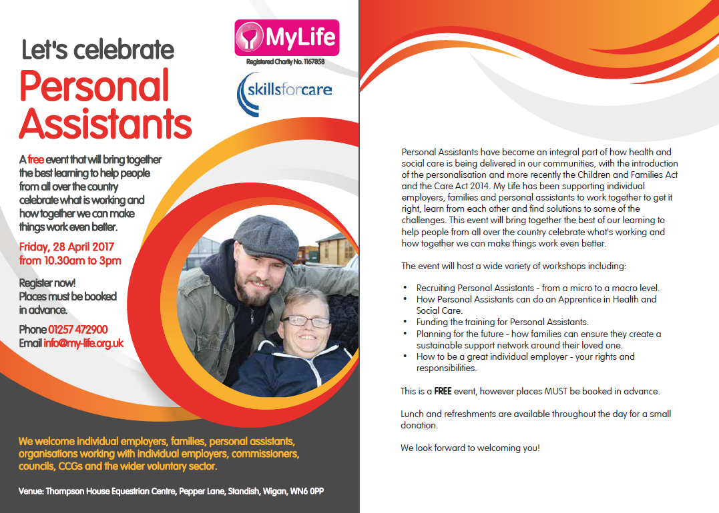
We had great feedback about the event – read the event evaluation here.

Find out more

You can download the workbook and supporting resources for the P2E course, using the links above.

If you’d like us to support you to deliver a similar model email carolinetomlinson@my-life.org.uk.

