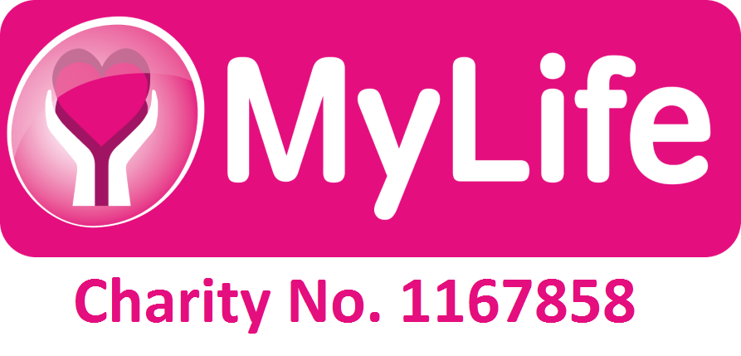

Top tips to remember if employing your own staff

- You should ask for help from the council – they need to offer you good advice and support on the responsibilities of being an employer.
- How are you going to find staff, have you thought of the type of people you need and what their job will entail?
- You will need to decide on your hourly rate – some people pay different rates depending on when their staff work, others keep the same rates regardless of when their staff work.
- Working out you staff rota may be a challenge – get someone to help you if you find this difficult.
- Having a timesheet to help you work out how much to pay your staff is always useful.
- Keeping accurate records about your staff is important as other Government departments can make requests that you are legally obliged to give.
- You will need to do a pay as you earn system – your local centre for independent living could organise this (which is often paid for by the council so is free to the end user) or a local firm of accountants (which you will be charged for).
- On top of your employee paying tax and national insurance you will have to pay EMPLOYERS national insurance which currently is 12.8% of anything of £96 per week that your employee is earning. (Check the latest figures with the Inland Revenue).
- If your staff are self employed you are still liable for their tax if they don’t pay it.
- You will need Employers Liability Insurance approximately £135 per year.
- You will need to give your staff holidays. The current minimum requirement is 5.6 weeks per annum pro rata (which means an equivalent to this even if they work part time).
- You cannot pay your staff in lieu of holidays, as this is against the working time directive.
- Get help in working out your staff holidays.
- Remember staff may take time off because they are sick or may go on maternity or paternity leave. You will have to provide cover for this and it may cost you money.
- You must decide what terms and conditions you are going to employ people under so having a contract is a good idea.
- You don’t need to give them a written contract a verbal one will do, but it is probably better if you do write it down so both parties know where they stand.
- Employing people is a big responsibility and you will need good advice if things don’t go well – but preventing things from going wrong in the first place is the best practice.
- But never forget employing people gives you the most choice, flexibility, control and often outcomes and many people choose to do it.
- For more information look up:-
- www.sds4me.org.uk
- www.acas.org.uk
- www.directgov.gov.uk



